Creating Audiobook from PDF

with Uses and Protection

***Abstract*— Digital audiobooks distributed over the Internet are a surprising shift in digital publishing. In recent years, audiobooks have ceased to be a peripheral by-product of print book at the center of digital publishing and reading, but which are still generally ignored in publication studies. [1] This paper is all about how to convert a PDF into an audiobook and all the benefits which are associated with it. It also describes how audiobooks are much more useful to the individuals and help them to retain more of the thoughts and learnings from the traditional methods. Further, it is also shows how converting the audiobook into multiple different languages can be done using a slight change in the code. This in turn is beneficial to the people of other regions who don’t speak English.**

**With the modern era and digitization, the electronic book and the growing popularity of the audiobook, it is very clear that the notion of reading and what constitutes a book needs to be revisited. That reading has always been done in many ways, and using different human senses, has long been clear to historians of reading. However, this is often overlooked in the contemporary emphasis on quiet, solitary reading performed using the eyes.**

**With convenient platforms and instant access to a wide range of audiobooks offered through multiple subscriptions services, these activities are becoming increasingly common. These new reading opportunities can lead to fundamental changes in reading practices. In addition, the introduction of digital audiobook subscription services also leads it is a change in the type of media adjacent to these books. The printed book was the closer of the two in format and practicality for other printed reading materials such as newspapers and magazines. The subscription audiobook is closer to other media distributed on the Internet and cloud computing, and which is consumed using screens and speakers, headphones, earphones, earphones, or headphones. The audiobook is therefore connected to the media such as music, movies, TV shows, digital radio, podcasts and other audio files or audiovisual content accessible via various digital platforms or streaming subscription services. These technical and commercial innovations can change reading practices perceived and how books are understood as objects.**

***Keywords***— **Audiobooks, Software, PDF, Technology, Audio technology, Digital books, Publishing, Podcasts**

1. INTRODUCTION

The use of audio recording as an educational intervention goes back to a strategy known as assisted reading. The assisted reading process begins when students listen an audio recording of a selection of text, followed by the teacher. When the teacher reads some texts independently, then experiments predicted that assisted or while listening to a fluent audio recording pattern would reappear as a viable approach to fluency teaching and as a method to improve students' attitudes towards reading.

Assisted reading isn't a form of primary literacy. It is rather used to serve as an intervention. Instructions serve as a scaffold (Vygotsky 1978) that allows students to read at an independent reading level.

Kelli J. Esteves and Elizabeth Whitten (2011) stated that the mode of delivery for assisted reading has changed over the years of human delivery, on audiotape, on compact disc, on Playaway devices, and in digital downloads. However, regardless of the medium used, the research results support the claim that assisted reading increases reading fluency, leading to better understanding and fluency for those who struggle to read. Experimentalists, Renee Michelet Casbergue and Karen H. Harris (1996) stated that assisted reading helps to the act of reading more enjoyable, providing students with a variety of commonly read literature models Assisted reading of self-selected texts allows readers with difficulties to absorb plots, pay attention to the plot and, as noted above, listen for a smooth pattern (Carbo 2005). All this evidence supported by previous research on assisted reading lends credibility that tells us that using audiobooks is important for a balanced reading program (Esteves and Whitten 2011). [2]

II. LITERATURE REVIEW

Reading comprehension and interest are essential for learning. The act of reading enables students to learn new vocabularies and concepts and access different types of reading materials. If students are behind in reading comprehension for their age/level, then students struggle to assimilate new vocabulary and concepts through the teachings of the textbooks and other publications.

Difficulty reading can result in poor academic performance due to the inability to process new vocabularies and concepts in a meaningful way. These difficulties can progress to students lose interest in reading and entering a state of learned helplessness. This can lead students to not function well in schools or colleges and drop out and have below average readings adult comprehension skills.

The audiobook is audible and auditory. This will obviously set you apart of the written work of which it is a performance, and the specific temporal delimitation of the auditory object must be approached in order to sense what we are learning while listening to an audiobook. At the same time, while comparing the audiobook with auditory objects of experience, such as music or speech from one gift to another, it must also be distinguished from these other objects. [3]

Sometimes it is difficult to call an audiobook a book since it is fundamentally different from the printed book in terms of technology, aesthetics, and use. However, we emphasize the bookish nature of the audiobook both for the sake of the source and because it is part of the institutionalized literary context constituted by authors, publishers, booksellers, libraries, etc. It follows from our definition that in this article, exclude text recordings as well as audio narratives without the coexistence of written book - formats that in other contexts would be considered audiobooks. However, we are aware that born audio formats can herald the future of audiobook development as evidenced by the Audible Originals initiatives.

As printed books evolved into audiobooks, changes took place in relation to the format of the book, the meaning used to consume the book, and, in a way, even the content.

In this remediation, many of the book's characteristics, that is, the qualities that signal to the user that it is a book, are renegotiated into audio files. With these quite dramatic changes, it is advantageous

with discussions that clarify the audiobook and its relationship with the printed book, as well as Audiobooks can be understood as books.

1. PODCAST v/s AUDIOBOOKS

Podcasts emerged in the early 21st century and grew in popularity along with the signature audiobook (Sullivan, 2019). Both are sometimes available on the same platforms and users can seamlessly switch between listening to an audiobook and a podcast, the various contents being consumed both by the sense of hearing and with the help of the same devices. This can make the two media look similar. However, a podcast is here primarily understood as more comparable to radio, television or certain YouTube content.

While audiobooks are recordings of books, podcasting is digital audio content consisting of interviews and conversations, as well as documentaries or similar narrative content on television Series. Just as books can be part of a series, with new episodes released regularly, so too some podcasts. However, podcasts tend to follow traditional radio and television broadcasting practical, consisting of seasons and episodes that air on a predictable schedule (Bottomley, 2015). Book publishing does not follow such frequent publishing patterns.[4]

However, there may be changes as some audiobook services have started to produce their own audiobook short stories in serial formats with installments released regularly. Those are often written directly to audio and appear to follow in the footsteps of podcasts, television shows serialized or perhaps in the tradition of Victorian serialized fiction. Additionally, some podcasts are turned into books, blurring the lines even more. These developments suggest that there may be more overlap between audiobooks and podcasts in the future as audio stories are rising.

Therefore, it may be necessary to revisit the discussion on the differences and the similarities between the two media. In this article, audiobooks are understood as books while podcasts are primarily understood as a different form of media.

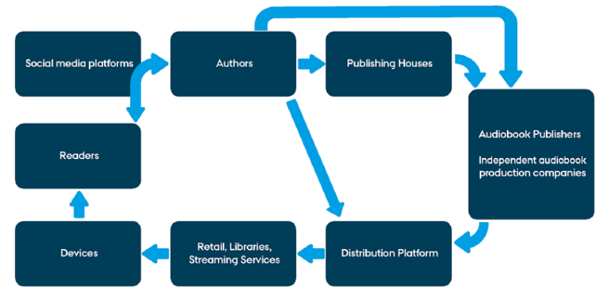

Fig. 1: A generic model of the circuit for digital, internet distributed audiobook publishing [1]

The objective is to try using Python and create a code that can be used to convert a PDF to an audio file that can either be read instantaneously or could be downloaded into the system and be used for later purposes. The priority is the first one.

1. IMPLEMENTATION

The python code is written is devised in such a way that it reads any pdf file into audio output. Any PDF can be used in order to read the file and has to be specified in the python file. The libraries which are used in Python are:

* 1. Pyttsx3

pyttsx3 is a text-to-speech conversion library in Python which works offline, and is compatible with both Python 2 and 3.

*Installation****:***

pip install pyttsx3

*Usage:*

import pyttsx3

engine = pyttsx3.init()

engine.say("I will speak this text")

engine.runAndWait()

* 1. Pypdf2

PyPDF2 is a free and open-source pure-python PDF library capable of splitting, merging, cropping, and transforming the pages of PDF files. PyPDF2 can retrieve text and metadata from PDFs and can add cutom data, view options and passwords to PDF files.

*Installation:*

pip install PyPDF2

*Usage:*

from PyPDF2 import PdfFileReader

reader = PdfFileReader("example.pdf")

number_of_pages = reader.numPages

page = reader.pages[0]

text = page.extractText()

* 1. Translate

Translate is a simple but powerful translation tool written in python with with support for multiple translation providers. By now we offer integration with Microsoft Translation API, Translated MyMemory API, LibreTranslate, and DeepL’s free and pro APIs.

*Installation:*

pip install translate

*Usage:*

$ translate-cli -t zh "This is a pen."

Translation: 这是一支笔

-------------------------

Translated by: MyMemory

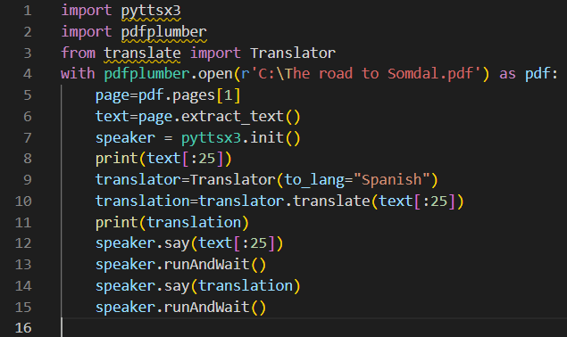

Fig. 2: Code for the Program Implementation

The PDF file present in here is named “OOP.pdf”. This file is opened in the read mode, i.e. no changes can be made to it right now and can only be accessed for reading purposes.

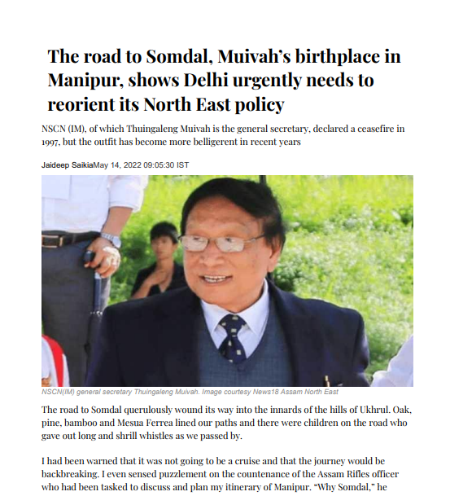

Fig. 3: The file is opened somewhere else in the File manager

Finally, the data is read by the program as soon as it is run and we can hear the audio.

1. OUTPUT

When the code is run, then the code reads the file and then the file is converted to audio and read out aloud. Now when there is a need to change the language, we change the language to the one which we need and run the program again. It converts the language first using the Translate library and then the audio is read out aloud. The following Screenshots show how changing the language in the code also translates the language.

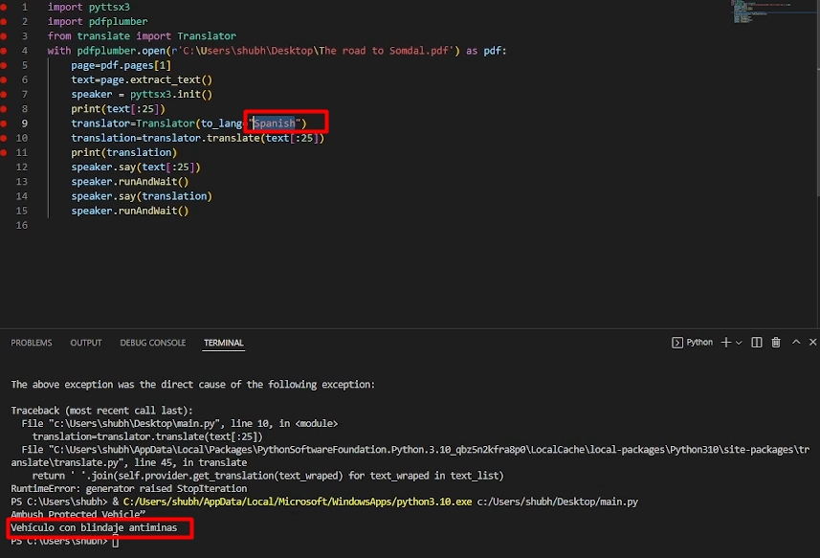

Fig. 4: Code for the Program with Spanish as a language

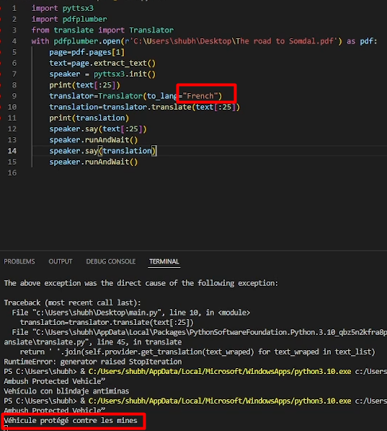

Fig. 5: Code for the Program with French as a language

1. PROTECTION OF AUDIOBOOKS

Audio watermarking is a promising solution for copyright protection for audio and multimedia products. To function as an effective tool to enforce ownership rights, any qualifying audio watermarking system must meet a number of requirements. Benchmarking any audio watermark technique is measured against these requirements.[5]

*A.* *Imperceptibility*

Imperceptibility is a prerequisite for practicality. The audio watermarking process is considered imperceptible or transparent if there are no differences between the host and the watermark signs are noticeable.[6] Otherwise, it is noticeable or not transparent. To preserve the quality of the watermarked data, a psychoacoustic test model derived from the auditory masking phenomenon will be invoked to deceive human perception of digital audio files.

*B.* *Robustness*

Robustness is a measure of reliability and refers to the ability to withstand a variety of unintentional and intentional attacks. In other words, the watermark detector must be able to extract the watermark from the attacked watermark signal. Examples of audio watermark attacks include many types of signal processing and encoding, such as noise addition, resampling, requantization, MPEG (Moving Picture Experts Group), random sample compression3, and time scale shift (TSM) and tone scale shift (PSM).

*C.* *Security*

Security is a prerequisite for existence. How to watermark algorithms are likely to be open to the public, we must ensure that watermarks do not be verified even by reversing the integration process or performing statistics detection.[7,8] In this case, secret keys (usually pseudo-random sequences) and/or scrambling operations can be adopted to add randomness to the integration and detection process, so that the watermark system is self-protected.

*D.* *Data Payload*

Data payload is the number of bits carried in a unit of time. In digital audio watermark is defined as the number of bits embedded in a one-second audio fraction, expressed in bit per second (bit/s or bps).[9] Audio data payload. The watermarking system varies greatly depending on the embedding settings and the embedding algorithm. Copyright protection apps do not require high data payload, only 2 4 bps on average.[10]

*E.* *Computational Complexity*

From a technological point of view, the computational complexity of a watermarking system involves two main issues to be considered. One is the speed with which integration and detection are performed, and the other is the number of integrators and detectors where speed is more of a concern.

The most intuitive way to estimate velocity is to separately measure the embedding and detection time versus host audio duration. For a fair comparison, the measurements must be performed on platforms with the same computing resources. While a real-time, low-delay system is generally desired, different applications require different speeds. For copyright protection purposes, even a commercial product doesn't care much about the coating time. On the other hand, customers expect to extract the watermark as quickly as possible.

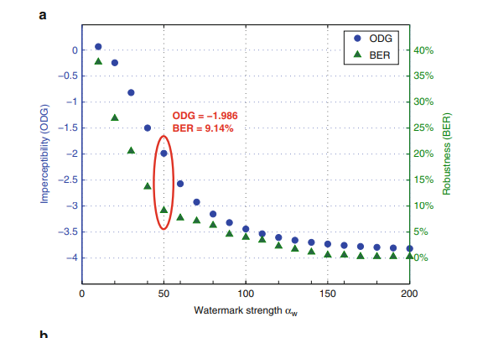

Fig. 6: Determination of watermark strength. αw[5]

1. CONCLUSION

While traditional uses such as leisurely reading and writing for the blind, are still the major challenge of audiobook collections, academic libraries are beginning, slowly and tentatively, to add audiobook titles for other uses. Thus, how to improve literacy, familiarize students with libraries and support programs..

Even though there are many complexities which are currently being faced by the researchers and other professionals to make the audiobooks into a mass available product, tireless efforts are being made to achieve it. The simple piece of code which has been used to read out the text book can be used in a lot of places to automate the making of the audiobooks in many affordable and convenient ways, with some improvements and enhancements in the code. There are many threats also which are also very much confined to audiobooks and hence the watermarking process has also been explained along with the benchmarks and pointers to keep it in mind of the safety measures.

The way books were previously read in the traditional print, they are now being modernized not only because of the digital era, but also to help those who are in actual need of this technology.

1. REFERENCES

[1] Have, I. and Pedersen, B.S., 2020. The audiobook circuit in digital publishing: Voicing the silent revolution. *New media & society*, *22*(3), pp.409-428.

[2] Whittingham, J., Huffman, S., Christensen, R. and McAllister, T., 2013. Use of Audiobooks in a School Library and Positive Effects of Struggling Readers' Participation in a Library-Sponsored Audiobook Club. *School Library Research*, *16*.

[3] Wittkower, D.E., 2011. A provisional phenomenology of the audiobook.

[4] Wallin, E.T., 2020. Reading by listening: conceptualising audiobook practices in the age of streaming subscription services. *Journal of Documentation*.

[5] Lin, Y. and Abdulla, W.H., 2015. *Audio watermark* (Vol. 146). Heidelberg: Springer.

[6] L. Boney, A.H. Tewfik, K.N. Hamdy, Digital watermarks for audio signals, in Proceedings of IEEE International Conference on Multimedia Computing and Systems, 1996, pp. 473–480.

[7] C.-P. Wu, P.-C. Su, C.-C.J. Kuo, Robust and efficient digital audio watermarking using audio content analysis, in Proceedings of SPIE Security and Watermarking of Multimedia Contents II, vol. 3971, 2000 , pp. 382–392

[8] W.-N. Lie, L.-C. Chang, Robust and high-quality time-domain audio watermarking subject to psychoacoustic masking, in Proceedings of IEEE International Symposium on Circuits and

Systems (ISCAS), 2001, pp. 45–48

[9] I.J. Cox, M.L. Miller, J.A. Bloom, J. Fridrich, T. Kalker, Digital Watermarking and Steganography (Morgan Kaufmann Publishers, San Francisco, 2008)

[10] S.J. Xiang, J.W. Huang, Histogram-based audio watermarking against time-scale modification and cropping attacks. IEEE Trans. Multimed. 9(7), 1357–1372 (2007)

[11] Casbergue, R.M. and Harris, K., 1996. Listening and literacy: Audiobooks in the reading program. *Reading Horizons: A Journal of Literacy and Language Arts*, *37*(1), p.4.